

Software engineering department
Braude college of engineering
Final Project – phase B (61999)

Playroom Action Analysis
Code: 26-1-D-2

By:
Victor Ryskin
Niv Cohen
Advisors:
Dr. Anat Dahan
Dr. Julia Sheidin

Link to Github: https://github.com/VictorRyskinB/PlayroomHAR

Table of Contents
Table of Contents 2
1. Problem and Background Review 4
2. What Was Achieved 5
2.1 General Description 5
2.2 Description of the Solution 5
Architecture (high level) 5
Operation (activity flow) 7
Key design decisions 8
2.3 The Development Process 9
2.4 Tools Used 9
2.5 Challenges and Solutions 10
2.6 Results and Conclusions 11
2.7 Lessons Learned 12
2.8 Project Metrics 14
Appendix A — User Guide 15
A.1 What the application does 15
A.2 Starting the application 15
A.3 One-time room setup (per camera position) 15
Calibrate the camera 15
Draw regions 19
Optional: (within Room Setup) blueprint and profile 19
A.4 Analyzing a session video 20
A.5 Reviewing results 20
A.6 Exporting 20
A.7 Built-in help 20
Appendix B — Maintenance Guide 21
B.1 Operating environment 21
B.2 Installation 21
B.3 Code organization 21
B.4 Data and file formats 22
B.5 Extending the system 22
B.6 Deprecated subsystems (kept for future work) 23

Problem and Background Review
Autism, or Autism Spectrum Disorder (ASD), is a neurodevelopmental disorder, characterized by persistent deficits in social communication and interaction as well as restricted and repetitive behaviors [1] , yet current diagnostic practice relies on parent interviews and direct clinical observation, processes that are slow, labor-intensive, dependent on scarce specialists, and largely subjective. In behavioral research settings, a common protocol records a child playing in an instrumented playroom and later annotates the recording by hand: which areas the child visited, what the child engaged with, and for how long. Converting hours of video into structured behavioral timelines is exactly the kind of repetitive, quantitative work that computer vision is suited to automate.
Prior work explores three sensing approaches. Direct human observation remains the most widely used [2] but cannot reliably capture fast, fleeting behaviors or precise start/end times. Wearable sensors (accelerometers, gyroscopes) are robust to lighting and occlusion but are intrusive; wearing them can alter the behavior of a child with ASD, undermining the recorded data. Video-based analysis is effectively non-invasive and has advanced rapidly with deep learning: pose-estimation pipelines (e.g., OpenPose skeleton features with classical classifiers) have reported high accuracy in distinguishing ASD from typically developing children in natural videos, and region-based activity-recognition systems (e.g., I3D + temporal convolutional networks) have classified autism-related actions in uncontrolled environments with weighted F1-scores around 0.83, indicating a strong balance between correctly positive predictions while catching most actual positive cases, proving it as a stable and reliable classification.
This literature, available at https://ieeexplore.ieee.org/document/11021886, also makes the limits clear: model performance is bounded by training-data domain gaps, behavioral interpretation is far harder than object recognition, and automated systems detect visual patterns without understanding intent. Computer vision is therefore best positioned as an annotation and measurement tool, not a diagnostic authority. That framing defined this project’s goal: not to classify ASD, but to give researchers an automated, objective way to extract behavioral metrics, where the child was, how much they moved, which play areas they engaged in and for how long, from ordinary playroom video recorded with a single consumer camera.

2. What Was Achieved

2.1 General Description
The delivered system is the Playroom Behavioural Annotator: a Windows desktop application (Python / PyQt6) that takes a video of a child in a playroom and produces structured, quantitative behavioral data. The application:
- detects the child in every Nth frame (users can choose N) in a video using YOLO object detection.
- tracks the child across frames with ByteTrack and converts the pixel trajectory into real-world floor coordinates via a one-time, 4-point camera calibration (homography);
- computes movement metrics: total distance, average speed, session duration, floor-coverage percentage, active vs. stationary episodes, and a speed-over-time series;
- computes region presence: researchers draw named zones on the video (e.g., “play mat”, “toy shelf”), and the system reports every entry/exit segment, dwell time and percentage, visit count, and first-visit latency per region;
- visualizes everything as a top-down path map and dwell-time heatmap, optionally drawn over a blueprint image of the room;
- saves all results to a per-video JSON file and exports a complete, styled Excel session report, the most important output, designed so researchers can compare sessions across children and dates in a widely used tool.
Target users are ASD researchers and clinical research assistants, technically literate but not programmers. The UI is therefore organized as a guided workflow (1 Open video → 2 Calibrate → 3 Run All → 4 Analysis), with per-room “profiles” that bundle a calibration, region set, and blueprint so that day-to-day use after initial setup is essentially one click. A built-in User Guide (Help menu) serves as the in-app user-help system.

2.2 Description of the Solution

A single mounted camera was positioned approximately 2 m above the floor to provide a wide view of the entire playroom. The room dimensions (2.5 × 5 m) are used during the calibration process to map image coordinates to the physical layout, enabling accurate region assignment, path tracking, and heatmap generation. Figure 1 shows an image of the playroom with the camera position and field of view, regions, and an example tracking path (trajectory).

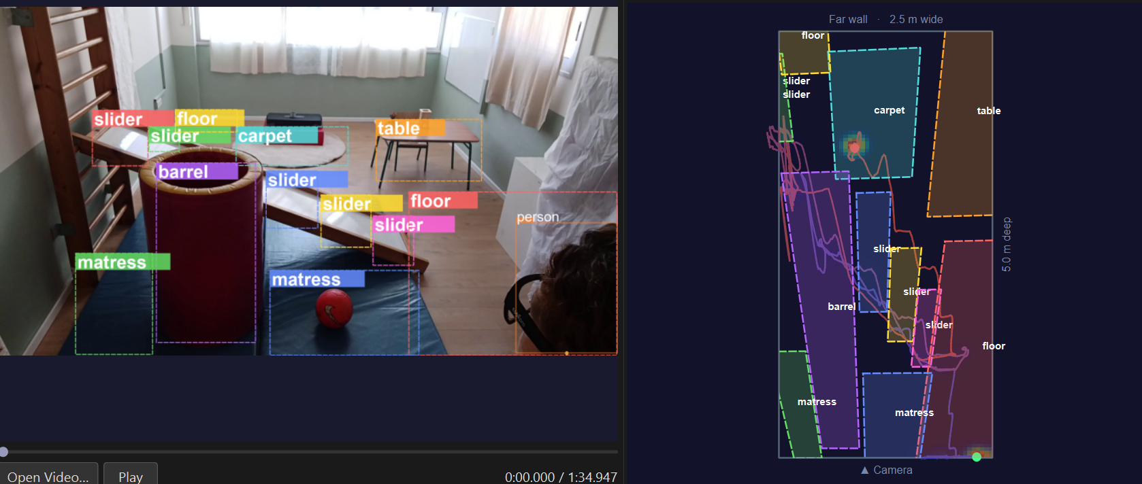
Figure 1: Camera Perspective with regions

Architecture (high level)
The application, as shown in Figure 2, is a single desktop process organized in two packages with a strict dependency direction where the backend never imports UI code.
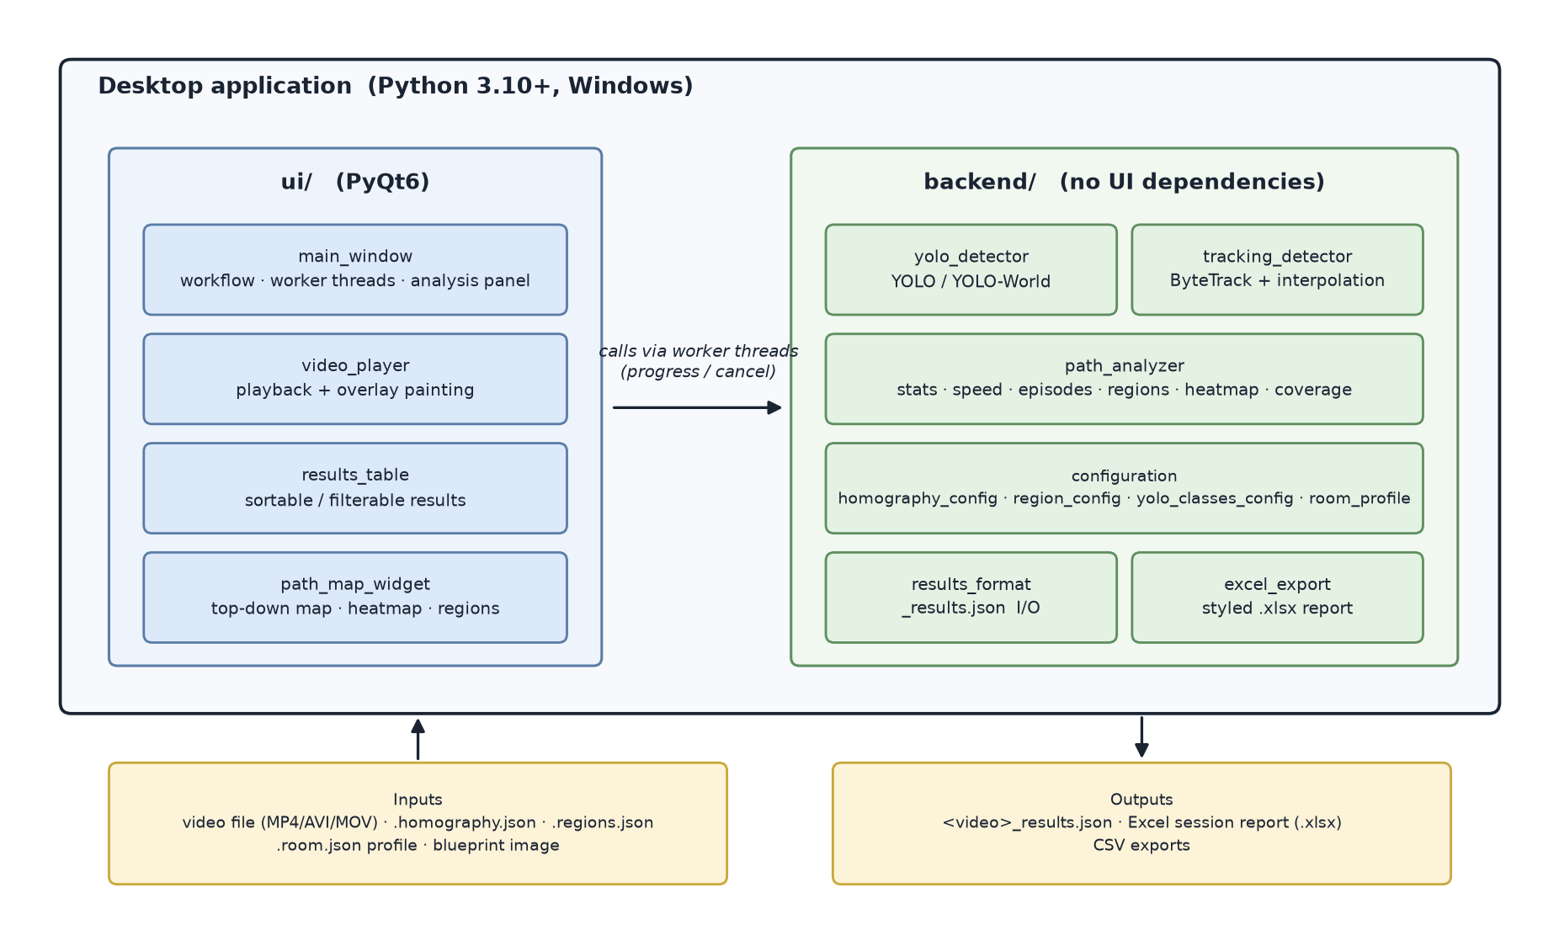
Figure 2: System architecture (package level)

Figure 3 illustrates the workflow of a typical analysis session. The main steps are as follows:
1. Open video (file dialog or drag-and-drop). If a _results.json from a previous run exists next to the video, it loads automatically.
2. Calibrate (once per camera position): the user clicks 4 known floor points in the frame and enters their real-world coordinates in cm; the app computes and saves a homography. Configure regions and a room blueprint the same way, and bundle them as a named room profile.
3. Run All: pass 1 runs YOLO detection over every sampled frame (always captured at a low confidence floor of 0.05 so thresholds can be changed later without re-running); pass 2 runs ByteTrack person tracking, selects the primary track, bridges short occlusion gaps (≤ 1.5 s) by linear interpolation, and projects the pixel path to floor coordinates.
4. Analyze: the analysis panel computes all metrics live from the stored data. Confidence threshold, smoothing window, stationary threshold, and minimum-episode duration are live filters, adjusting them updates every view instantly with no re-run.
5. Export: per-view CSV or the full Excel session report.

Operation (activity flow)
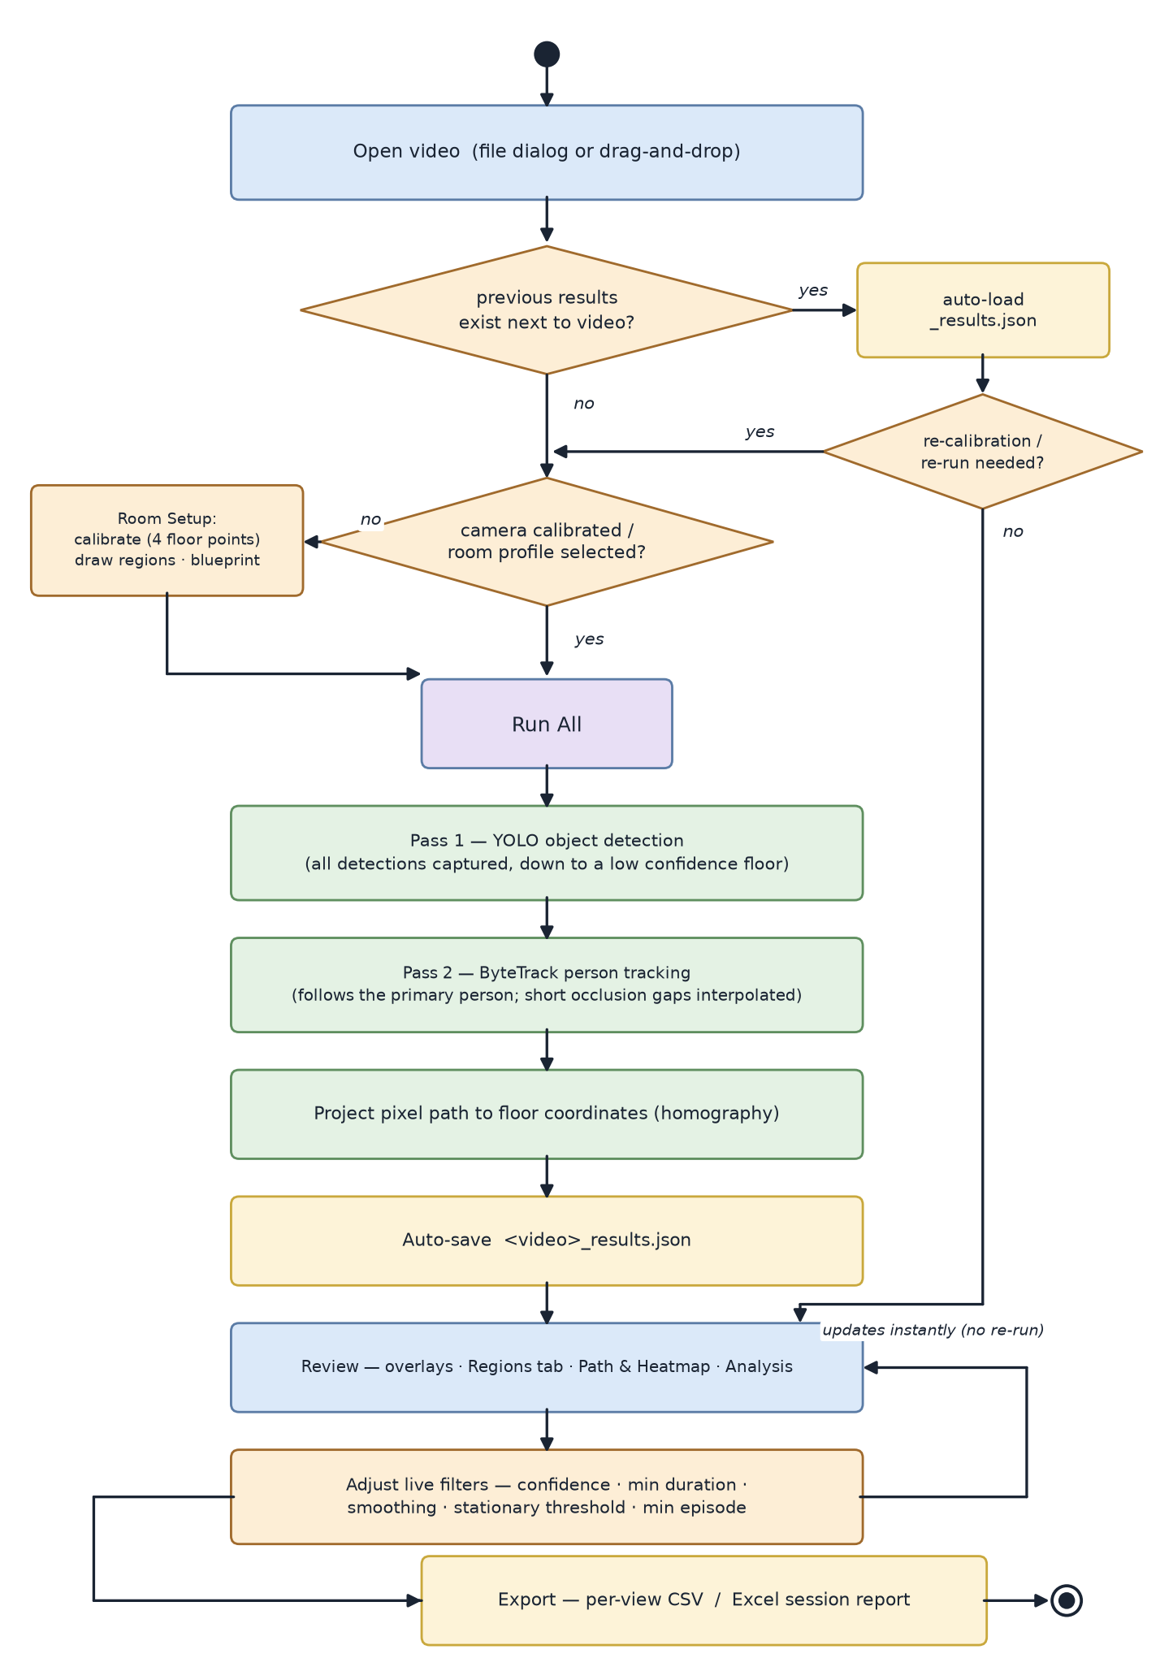
Figure 3: Activity diagram of a typical session

Key design decisions
- Capture-low, filter-live. YOLO always records every detection at confidence ≥ 0.05 into the JSON; the UI threshold is a display filter. Researchers can tune sensitivity in real time instead of waiting minutes for a re-run; this single decision removed the biggest usability bottleneck of the early prototypes.
- Pixel coordinates are the single source of truth. The tracker stores raw pixel points; world coordinates are derived through the current homography. Changing or fixing a calibration therefore reprojects the entire loaded path instantly, no reprocessing.
- Remembers settings. When reopened, the program uses the same settings and configurations as used on the previous run.
- Excel as the comparison surface. Cross-session comparison deliberately happens in Excel rather than in new in-app views: Excel is a widely used tool, and a complete styled workbook per session (summary, rendered maps, episodes, regions, speed series, raw points) is more future-proof than bespoke UI.

2.3 The Development Process
The project was developed iteratively, with the direction reshaped by evidence from real footage and researcher feedback. The git history documents the arc:
Stage 1 — Phase A architecture implemented as designed. The initial builds implemented the Phase A plan in full: YOLO object detection plus MMAction2 action recognition, an interaction mapper (child–object IoU and proximity), a segment builder producing (start, end, action, object) rows, a CLI mode, and a Google Colab notebook for GPU processing. Batched YOLO inference was added for GPU throughput, and the four capabilities, object interaction, action recognition, region capture, and path tracking, were brought to a demonstrable state.
Stage 2 — the demo meeting and the pivot. All four capabilities were demonstrated to the researchers in a working-demo meeting. The meeting produced the single most important finding of the project: object-interaction detection and action recognition, even when they work, do not produce output at the level of detail the researchers actually need (see Section 2.5, Challenge 1 — a closed-vocabulary action label like “playing with ball” collapses the qualitative distinctions their behavioral coding depends on). Path tracking and region capture, by contrast, produced exactly the kind of objective, quantitative data the researchers could use directly. Following this meeting, the MMAction2 pipeline and the object-interaction mapping were removed (retained in the repository in deprecated form), and the project was re-scoped around movement and region-engagement measurement.
Stage 3 — Refining the measurement tool. We built ByteTrack tracking with occlusion interpolation, homography calibration, the path/heatmap views, the movement-analysis panel (episodes, speed graph, coverage), and path-based region presence. Region containment was refined from whole-bounding-box overlap to a foot-position test (the bottom of the person’s bounding box, i.e., the floor contact point), after whole-box overlap produced false region hits when the child’s upper body merely overlapped a zone on screen.
Stage 4 — Hardening for real users. The following was refined: cancellation of long runs, CSV export, live path mode, settings persistence, and calibration fixes. Later iterations added the Excel session report, data-integrity fixes (one metric definition everywhere), room profiles, the guided step workflow, drag-and-drop, and the built-in user guide. We optimized playback performance so the annotated video runs smoothly on modest hardware.

2.4 Tools Used
Table 1 presents the tools used.
Table 1: Tools used
Purpose | Tool
Language / runtime | Python 3.10+
Object detection | ultralytics YOLOv8 (n/s/…) and YOLO-World (open-vocabulary)
Person tracking | ByteTrack (via ultralytics model.track)
Geometry / video I/O | OpenCV (homography, containment tests, playback)
Desktop UI | PyQt6
Plots and rendered maps | matplotlib (Agg)
Excel report | openpyxl + Pillow
Experiment phase (dropped) | MMAction2 (PyTorch / OpenMMLab), Google Colab
Version control | Git / GitHub

2.5 Challenges and Solutions
1. Action labels are too coarse for behavioral research (the decisive challenge). Action recognition outputs a closed-vocabulary label, “playing with ball”, “stacking blocks”. At the demo meeting, we learned that this is not the level of detail the researchers work at. Even a perfectly accurate detection collapses all nuance into a single label. Closing that gap would have required a bespoke label vocabulary and an annotated child-behavior dataset to train on, which is far beyond the scope of this project. Following discussions with the research team, the project scope was refined by excluding action recognition and object interaction labeling from the final system, and refocus on position, movement, and region engagement, signals that are reliably measurable and directly useful.
2. From pixels to meaning (engineering). Raw tracking gives pixel trajectories that depend on camera placement. By tracking the child's foot position and applying homography calibration, the system projects image coordinates onto the floor plane, reducing perspective ambiguity and enabling accurate spatial measurements from a single camera (Figure 1). Storing pixel coordinates as the source of truth and deriving world coordinates makes recalibration inexpensive, since updated calibration parameters instantly reproject all trajectories.
3. Tracker noise vs. real metrics (data/algorithms). Single-frame jitter produced absurd instantaneous speeds. We addressed this with a centred rolling-average smoothing window applied uniformly, a minimum-episode duration that merges noise-induced micro-episodes, and the removal of the “peak speed” metric, which was dominated by jitter and could have misled researchers. Reporting fewer, trustworthy numbers was chosen over more, fragile ones.
4. Occlusions (technical). The child regularly disappears behind furniture. Gaps of up to 1.5 s are bridged by linear interpolation, and interpolated points are explicitly flagged in the data (dotted on the map, counted in the stats). The system assumes a single child in frame, a stated project assumption; if another person is briefly visible (e.g., a researcher), tracking follows the person seen in the most frames.
5. Long runs on modest hardware (technical/UX). Full-video inference takes minutes. Mitigations: frames are passed to the detector in batches internally rather than one at a time; a frame-stride option allows fast preview passes; detection runs in background threads with progress and cancellation; and the capture-low filter-live design means tuning a threshold never requires reprocessing.

2.6 Results and Conclusions
What was delivered. The re-scoped system was fully implemented and is operational end-to-end: a video goes in; a tracked floor path, movement metrics, region-presence segments, heatmaps, and a complete Excel session report come out, through a guided workflow usable by non-programmers. All functional requirements of the re-scoped system are met, and the non-functional requirements from Phase A that survived the pivot (modularity, maintainability, usability, transparency) are met as described in Section 2.8.
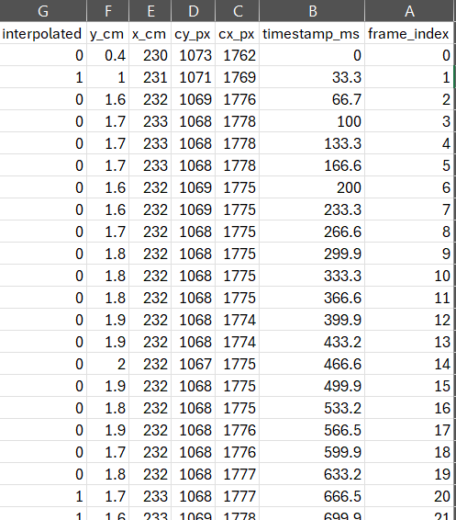
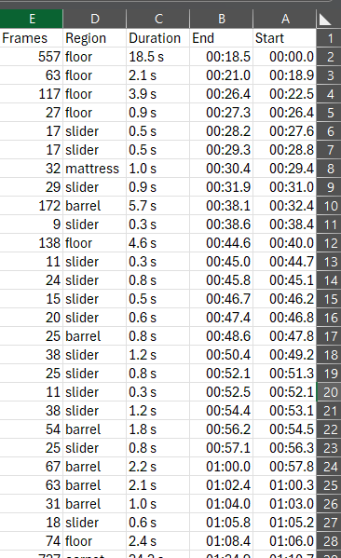
In the graphical user interface (GUI), the application provides export buttons that allow users to save the generated results in CSV format. The exported files include both the table of identified regions and the corresponding path data. Examples of these files are presented below in Figures 4 and 5.
Figure 4: Excel "Path Points" export
Figure 5: Excel 'Regions' Export

What was not achieved as originally defined. Two departures from the Phase A plan must be stated plainly:
Automatic action labeling was abandoned. As detailed in Sections 2.3 and 2.5, this was a deliberate scoping decision made with the researchers after the demo meeting, on utility grounds rather than feasibility grounds alone: coarse action labels cannot represent the qualitative distinctions that ASD behavioral coding requires. We consider the pivot itself a correct engineering outcome. The alternative was spending the semester polishing output nobody would use.
The two sub-systems, object-interaction detection and action recognition, were functional at demo level, though parameters such as detection thresholds and overlap percentages were never fine-tuned. The first watched where the child was relative to the toys: whenever the child's outline in the video touched or came near a toy's outline, the system recorded it, and strings of such moments became rows in a table. for example, "0:41 - 0:55, child interacting with ball". The second tried to name what the child was doing: it ran a rolling window over the video and had a pretrained action-recognition model (MMAction2) pick the best matching label from its vocabulary, such as "throwing" or "stacking blocks", listed in a table of its own. Together they were intended to produce a single timeline of the child's activities, with the action label taking precedence over the interaction rows thanks to its richer description: "throwing ball" rather than a bare "interaction with ball". Both systems were shown working at the demo and are kept on the demoVersionSnapshot branch.
Quantitative validation against human annotation was not performed. The Phase A evaluation plan (segment agreement at TIoU ≥ 0.9) was defined for action segments and presupposed researcher-annotated ground truth. When action recognition was dropped, the metric lost its object; and human-annotated data was only ever discussed in the context of actions. No annotated position or region-presence data for playroom sessions ever existed. The system’s correctness was therefore established at the level of face validity and internal consistency rather than statistical agreement:
- Every intermediate result is inspectable: bounding boxes, the tracked trail, and region outlines are drawn directly on the video, so tracking correctness can be visually verified frame by frame while scrubbing;
- Each metric is computed in one place, and every table and export reads from it, so two views cannot show different numbers;
- Calibrated distances and speeds fall in plausible human ranges, and the system deliberately refuses to report physical metrics for uncalibrated sessions rather than output pixel-based pseudo-values;
- Run settings, confidence scores, and interpolation flags are recorded in every saved result.
Conclusion. The project goal, as re-scoped with the researchers, was achieved: an objective, automated, non-invasive measurement tool for movement and region engagement in playroom sessions, packaged for real research use. The original Phase A goal was partially achieved by conscious decision, and the reasoning for that decision is itself one of the project’s main results.

2.7 Lessons Learned
- Validate utility before building; a survey would have been cheaper than a demo. The action-recognition and object-interaction pipelines were fully built and integrated before the demo meeting revealed that their output was not useful at the researchers’ level of detail. In hindsight, the same conclusion could have been reached in a fraction of the time by collecting existing examples of similar products and published systems and showing the researchers sample output, “this is the kind of label you would get”, before implementing anything. The demo did its job, but it was the most expensive possible way to learn that lesson.
- Document features when they are written, not when someone asks. Early in the project, a feature would be designed and implemented by one of us without being written down anywhere. When the other pulled the latest version, the only way to learn what the new control did was to ask, and the answer had to be reconstructed from memory, nuance by nuance. After one such episode, we made it a rule that every new feature or behavior change is documented the moment it lands; the in-app user guide is maintained as part of any change to user-facing behavior.

2.8 Project Metrics
Phase A defined five self-set metrics (NFR1–NFR5). Their status at the end of Phase B:
Table 2: FR NFR table. Metrics and outcomes
Metric (self-defined in Phase A) | Target | Outcome
NFR1 — Accuracy (agreement with manual annotation) | Segment agreement with human annotation at TIoU ≥ 0.9 | Not evaluated. The metric was defined for action segments, which were removed in the re-scope, and it presupposed researcher-annotated ground truth that never existed; human annotation was only ever discussed for actions. See Section 2.6 for the face-validity verification performed instead.
NFR2 — Modularity | Separable detection / tracking / analysis / export modules | Met. Backend modules are UI-independent and individually replaceable; deprecated modules were removed without touching the rest.
NFR3 — Maintainability | Documented, adjustable parameters | Met. All thresholds are UI-adjustable and persisted; per-room configurations are portable files; conventions documented for future maintainers (Appendix B).
NFR4 — Usability | Minimal manual work after setup | Met. After one-time room setup: open video → Run All → Export. Live filters eliminate re-runs for parameter changes.
NFR5 — Transparency | Intermediate outputs accessible | Met. Raw detections, confidence scores, and interpolation flags are stored in the JSON; every overlay is visible in-app.

2.9 Outputs and Comparisons
This section compares the system's outputs across several sessions. The goal is to show that different children produce different maps and that those differences say something useful with regards to ASD about how each child moved and played.
All sessions were recorded in the same room with the same camera position and room profile (calibration, regions, and floor dimensions), so differences between maps reflect the children's behavior, not the setup.

Sessions
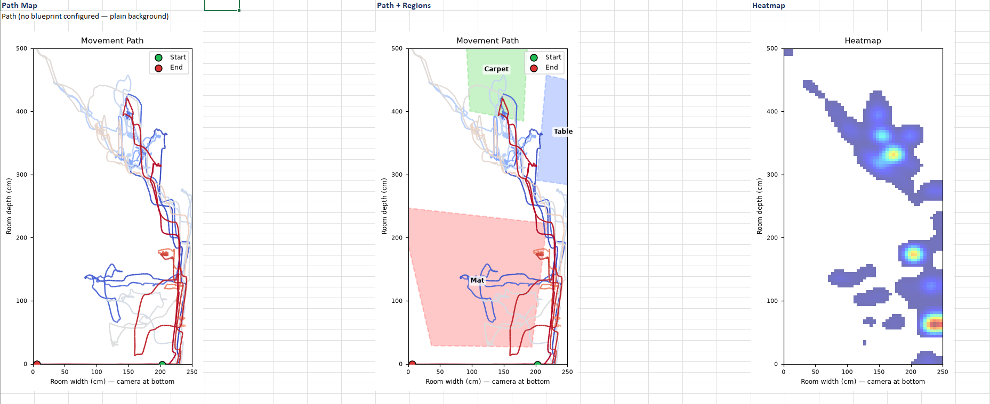
Figure 6: Path map and Heatmap of participant #10 (PT10)

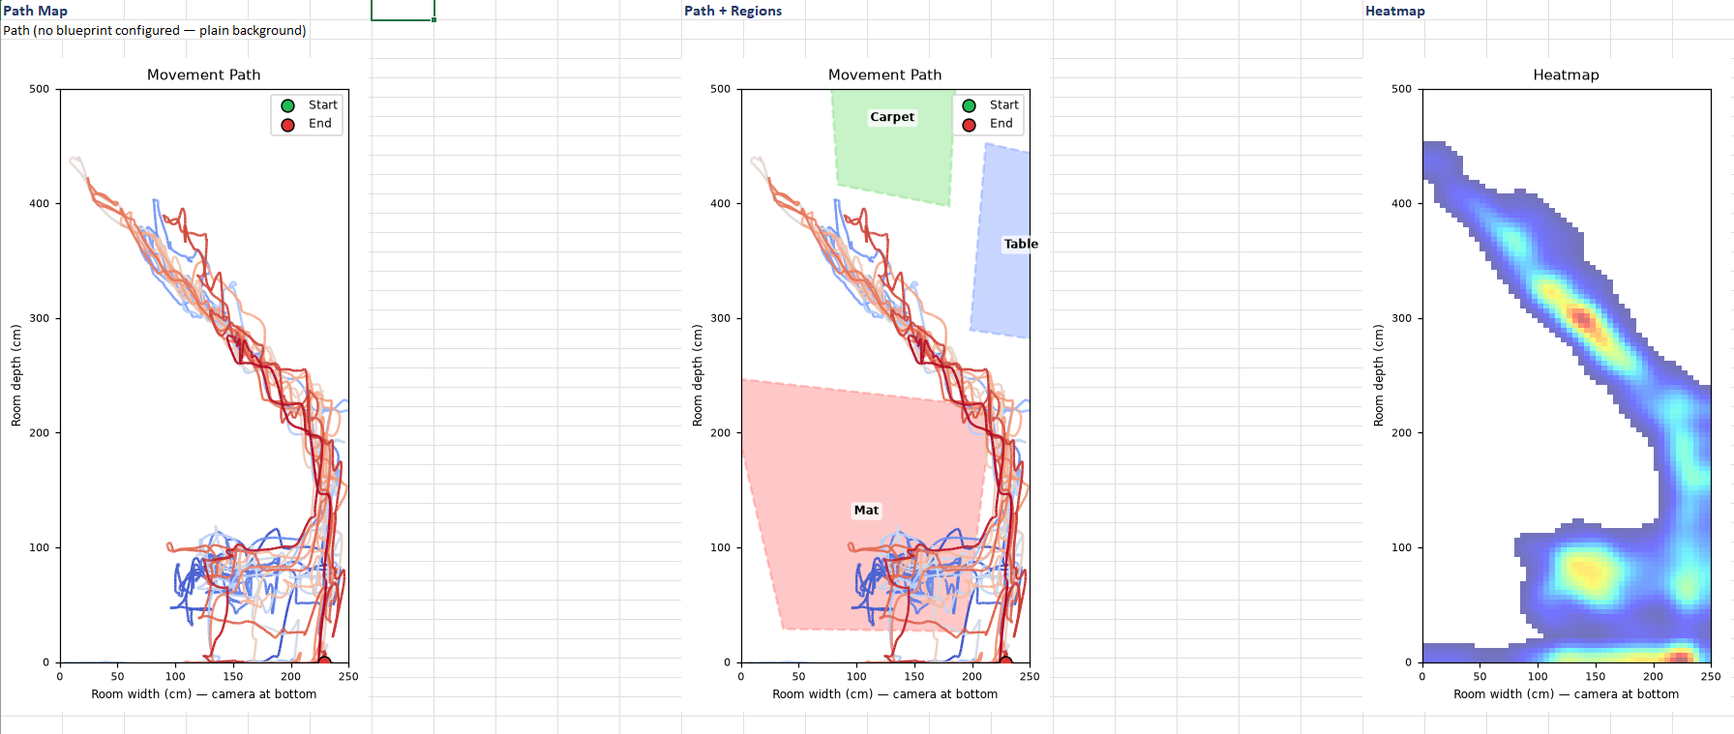
Figure 7: Path map and Heatmap of participant #12 (PT12)

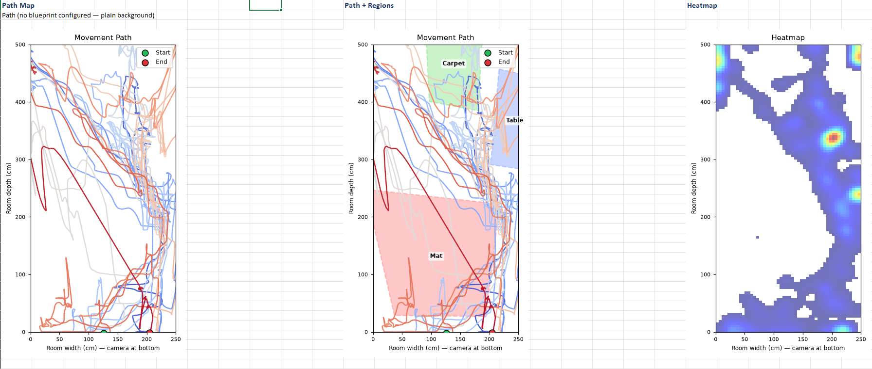
Figure 8: Path Map and Heatmap of participant #9 (PT9)

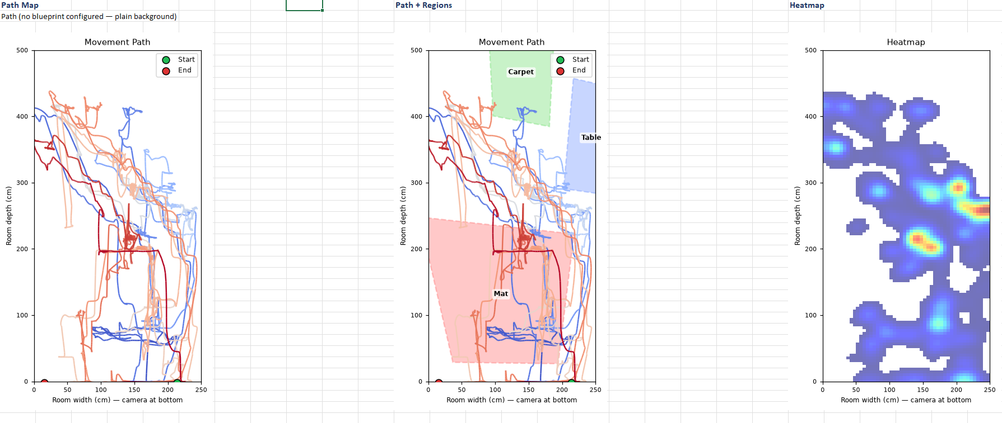
Figure 9: Path Map and Heatmap of participant #11 (PT11)

The four sessions (Figures 6-9) show a wide range of movement styles. Some children confined themselves to a strict route or a small set of zones. In Figure 7, nearly every traversal collapses onto the same diagonal corridor, and the heatmap reduces to a single ribbon with two concentrated dwell spots. Other children ranged over the entire floor. Figure 8 shows long sweeps reaching the edges and corners of the room while the center remains almost untouched, and Figure 9 shows broad, overlapping coverage, with dwell time spread across many locations instead of pooled in a few. The movement character also differs: confined sessions tend to show smooth, parallel strands from repeated traversals of the same route, while wider-ranging sessions are more jittery, with abrupt changes in direction. Note that some of the long straight segments are interpolations, where the tracker briefly lost the child and bridged the gap in a straight line.
References
[1] Zhang, Y., Tian, Y., Wu, P., & Chen, D. (2021). Application of skeleton data and long short-term memory in action recognition of children with autism spectrum disorder. Sensors, 21(2), 411.‏
[2] Harrop, C., McConachie, H., Emsley, R. et al. Restricted and Repetitive Behaviors in Autism Spectrum Disorders and Typical Development: Cross-Sectional and Longitudinal Comparisons. J Autism Dev Disord 44, 1207–1219 (2014). https://doi.org/10.1007/s10803-013-1986-5

Appendix A — User Guide

A.1 What the application does
The Playroom Behavioural Annotator analyzes a video of a child in a playroom and produces movement and region-engagement metrics: the child’s path on a floor map, a dwell-time heatmap, distance/speed/activity statistics, time spent in named room regions, and a complete Excel report.

A.2 Starting the application
1. Double-click the application shortcut, or run python main.py from the installation folder.
2. The main window opens with a step bar showing the workflow: 1 Open video → 2 Calibrate → 3 Run All → 4 Analysis. Completed steps show a green check; the suggested next step is highlighted. Each step is clickable.
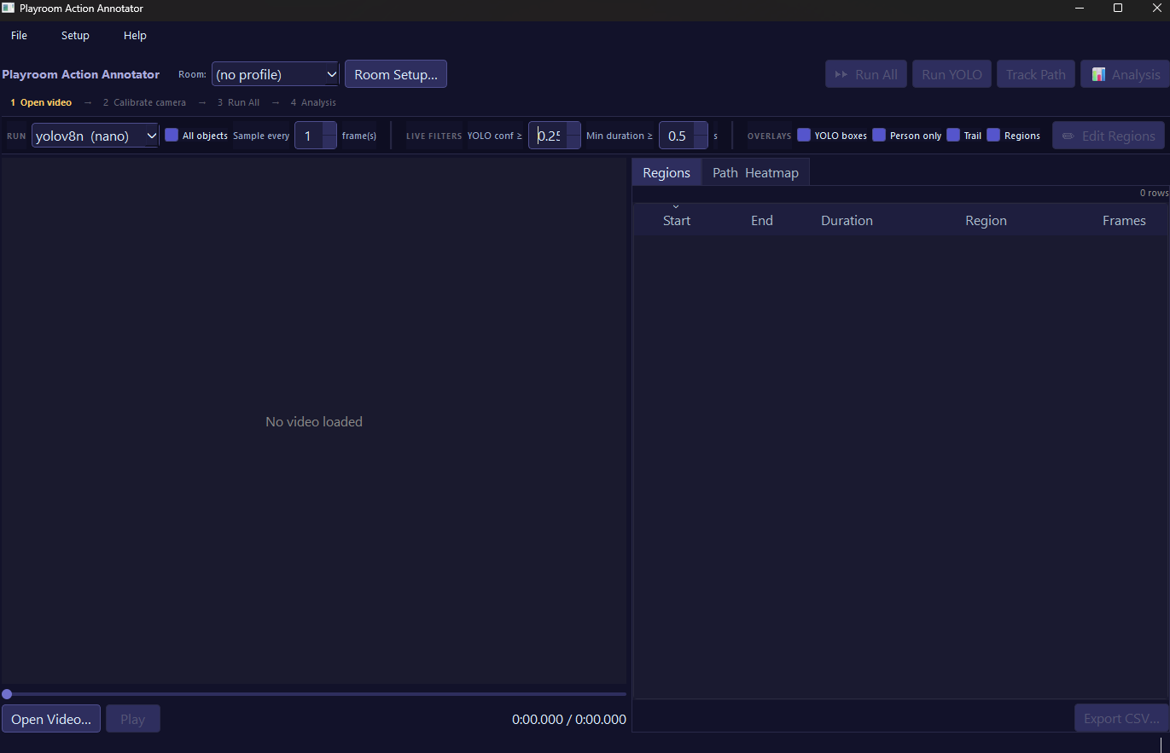

A.3 One-time room setup (per camera position)
Everything configured once per room lives in Room Setup… (toolbar button or Setup menu). The dialog stays open while you work.

Calibrate the camera
1. Click Calibrate new… (or step 2 in the step bar).
2. Enter the room width and depth in centimeters.
3. Click 4 known points on the floor in the video frame; for each, type its real-world X, Y position in cm. Origin is the front-left corner (camera side, left); X runs across the room width; Y runs toward the far wall.
4. The calibration is saved automatically as a .homography.json file next to the video and auto-loads next time.

Visual guide:
Step 1: Click Calibrate Camera (Option 1) or click Room Setup and Calibrate new (Option 2). Enter the room’s dimensions.
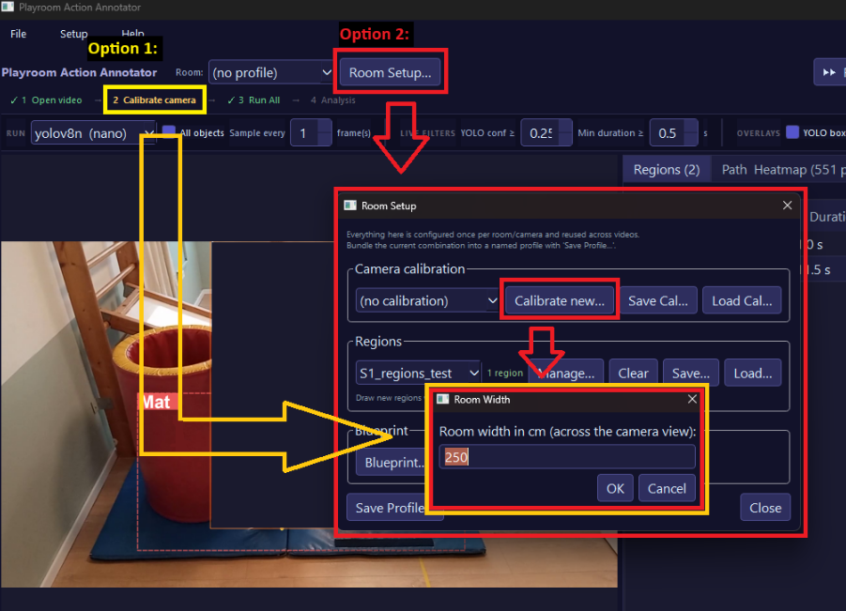
Step 2: Click on a corner of the floor in the room and enter its XY position. Do this for all four corners (only points x = 0, y = 0 [1/4] and x = 250, y = 500 [3/4] are illustrated in this guide).
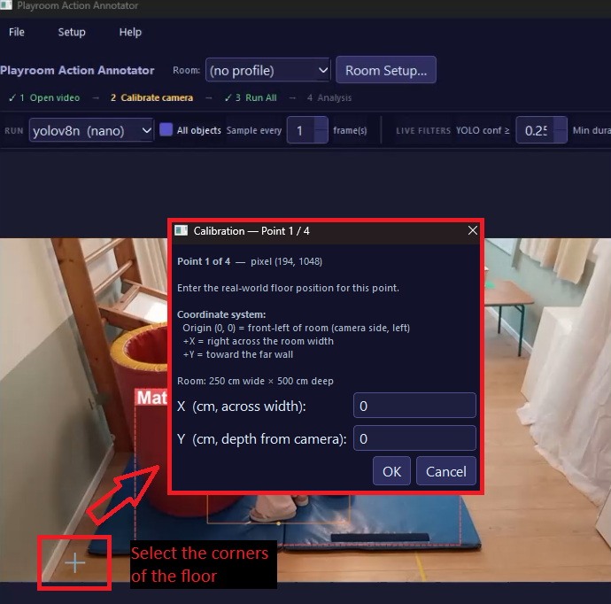
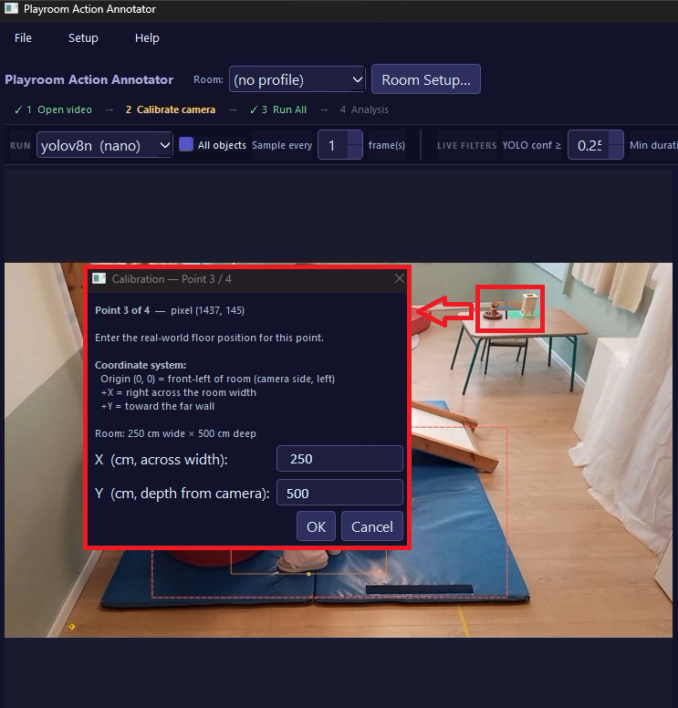
Step 3 (optional): save the camera calibration under a unique name for a specific camera setup
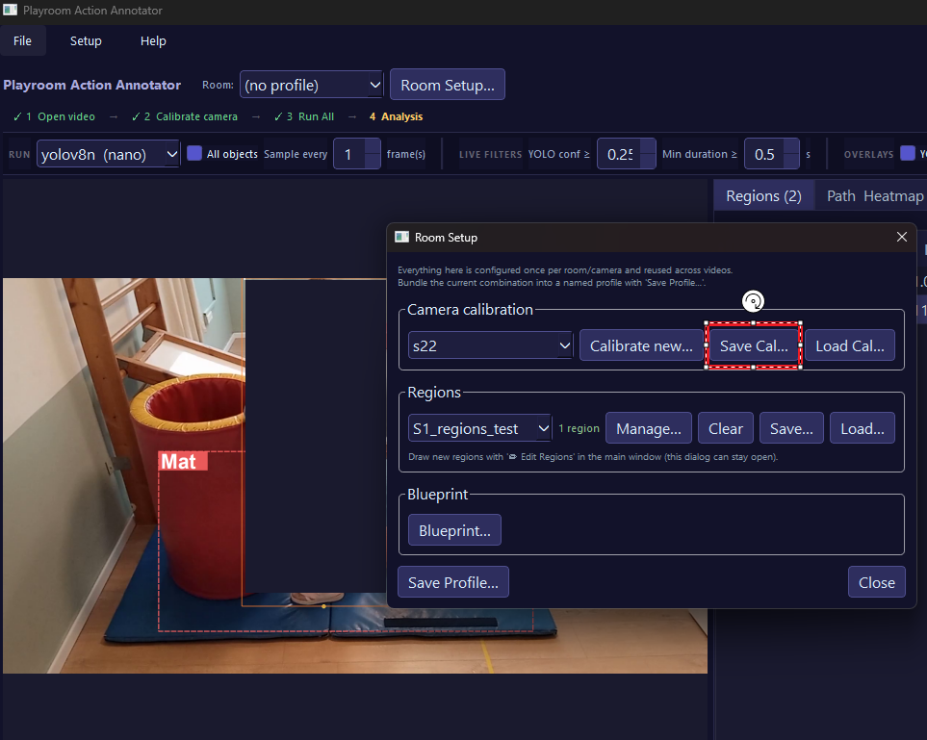

Draw regions
1. Toggle Edit Regions in the parameter bar, then drag a rectangle over an area of interest in the video (e.g., “Play mat”).
2. Name it when prompted. Repeat for each zone.
3. Toggle off when done
4. Save Regions in the Room Setup window; it writes them to a .regions.json file.

Optional: (within Room Setup) blueprint and profile
- Blueprint… loads a top-down image of the room, drawn under the path map and heatmap (orient it with the camera side at the bottom).
- Save Profile… bundles the current calibration + regions + blueprint under one name. From then on, picking the profile from the Room: dropdown in the toolbar applies all three at once.

A.4 Analyzing a session video
1. Open the video: File → Open Video…, or drag the file onto the player (MP4, AVI, MOV, MKV, WMV).
2. Confirm the correct room profile is selected in the toolbar.
3. Click Run All. The app first detects objects in every Nth frame (YOLO), then tracks the child’s path (ByteTrack). Progress is shown; Cancel is available. Expect the combined run to take roughly twice as long as a single pass — detection and tracking are separate passes over the video.
4. Results save automatically to <videoname>_results.json next to the video, and reload automatically whenever you reopen that video.

A.5 Reviewing results
- Video overlays: bounding boxes and the tracked trail can be toggled in the parameter bar. The YOLO conf and Min duration controls are live filters — dragging them updates the results instantly, with no re-run.
- Regions tab: every time segment the child spent inside each named region.
- Path & Heatmap tab: top-down path (blue→red = early→late; dotted = interpolated), dwell-time heatmap, and region outlines. Live path grows the path as you scrub the video.
- Analysis panel (click Analysis): summary metrics (distance, average speed, duration, floor coverage, active/stationary breakdown), a speed-over-time graph (click to seek the video), an episode’s table (click a row to seek), per-region dwell statistics, and a full-screen path map. The smoothing window, stationary threshold, and minimum-episode duration update everything live.

A.6 Exporting
- Export CSV exports the currently visible analysis view.
- Export Excel writes the complete session report to one styled workbook: summary, rendered path/heatmap images (over the blueprint if set), episodes, region metrics, region segments, speed series, and all path points.

A.7 Built-in help
Help → User Guide opens the full in-app guide covering every control, including tips (e.g., recalibrate whenever the camera moves; raise “Sample every N frames” for a fast preview on long videos).

Appendix B — Maintenance Guide

B.1 Operating environment
Component | Requirement
OS | Windows 10/11 (developed and tested)
Python | 3.10 or newer
Hardware | Any modern CPU; NVIDIA GPU with CUDA optional but strongly recommended for full-video runs
Disk | ~5 GB for Python environment + model weights; results JSON ≈ tens of MB per video
Input | Standard video files (MP4/AVI/MOV/MKV/WMV) from a single fixed camera

Python package dependencies (from requirements.txt): PyQt6 ≥ 6.4, opencv-python ≥ 4.8, ultralytics ≥ 8.0, matplotlib ≥ 3.7, openpyxl ≥ 3.1, Pillow ≥ 10.0. YOLO model weights (yolov8n.pt, yolov8s.pt, YOLO-World variants) download automatically on first use via ultralytics, or can be placed in the project root.

B.2 Installation
git clone https://github.com/VictorRyskinB/PlayroomHAR
cd playroom_har
python -m venv .venv
.venv\Scripts\activate
pip install -r requirements.txt
python main.py

For GPU acceleration, install a CUDA-enabled PyTorch build per pytorch.org before ultralytics resolves its dependency (standard PyTorch installation, no project-specific steps).

B.3 Code organization
playroom_har/
main.py entry point (desktop UI; CLI mode disabled — see B.6)
ui/
main_window.py main window: workflow, worker threads, analysis panel, dialogs
video_player.py OpenCV playback + overlay painting
results_table.py sortable/filterable results table
path_map_widget.py top-down floor map: path, heatmap, regions, blueprint
backend/ no Qt imports — reusable headless
yolo_detector.py YOLO / YOLO-World detection (batched)
tracking_detector.py ByteTrack person tracking + gap interpolation
path_analyzer.py PathPoint/PathStats, speed series, episodes, region stats,
heatmap, coverage — the analytics core
homography_config.py .homography.json save/load
region_config.py .regions.json save/load (normalised coordinates)
yolo_classes_config.py .classes.json save/load (YOLO-World class lists)
room_profile.py .room.json profile bundles
results_format.py <video>_results.json save/load (compact JSON)
excel_export.py styled .xlsx session report

Architectural rules for maintainers:
- backend/ never imports PyQt6. All UI lives in ui/; long tasks run in QThread workers defined in main_window.py with cooperative cancellation.
- Pixel coordinates are the source of truth. World (cm) coordinates are always derived via the active homography; calibration changes reproject rather than reprocess.
- YOLO captures at confidence 0.05 (CAPTURE_CONF_FLOOR); every UI threshold is a display-time filter over stored data.
- One smoothing window and one region-containment definition feed every view, the JSON, and the Excel export — extend those single functions rather than adding parallel computations.
- User-visible behavior changes must be reflected in the in-app guide (_UserGuideDialog._GUIDE_HTML).

B.4 Data and file formats
File | Contents
<video>_results.json | All results for one video: raw detections, track points, path stats (with smoothing window), run settings. Written compact (no indentation) — files hold 10k+ detections. Sections are upserted per run type.
*.homography.json | 4-point camera calibration (pixel↔cm homography + room size)
*.regions.json | Named regions in normalised (resolution-independent) coordinates
*.classes.json | YOLO-World class list
*.room.json | Room profile: named references to a calibration, regions file, and blueprint (loose bundle — components stay individually swappable)

thresholds/spinboxes, model selection, YOLO-World classes, font/theme, recent calibration/region/profile files, last profile, and blueprint path persist via QSettings.

B.5 Extending the system
- New metric: add a function/dataclass to backend/path_analyzer.py, surface it in the analysis panel, and add it to excel_export.py. The Excel workbook layout is the contract with researchers, prefer extending it over adding new in-app views.
- New YOLO model: add an entry to YOLO_MODEL_OPTIONS in backend/yolo_detector.py
- New export: follow excel_export.py (matplotlib Agg render → openpyxl embed).

B.6 Deprecated subsystems (kept for future work)
The repository retains several removed subsystems in deprecated form (marked DEPRECATED in the source): the MMAction2 action-recognition module (backend/action_recognizer.py), the child–object interaction mapper and segment builder (backend/interaction_mapper.py, backend/segment_builder.py), headless CLI mode (main.py), and the Colab notebook (colab/). Re-enabling the CLI requires reworking it against the current YOLO + path-tracking pipeline. Action recognition should only be revisited with domain-specific training data.
Explicitly out of scope by design decision: multi-camera support, ArUco automatic calibration (the manual 4-click flow is the shipping calibration), and cross-session comparison inside the app (done in Excel by design).

